**Problem statement**

**Recommend a best book based on the author, publisher and ratings.**

**Ans:**

> library("recommenderlab")

> library(caTools)

**Books rating data**

> books1 <- read.csv(file.choose())

> books <- books1[-c(1,2)]

> View(books1)

> View(books)

**Metadata about the variable**

> str(books)

'data.frame': 5000 obs. of 4 variables:

$ Book.Title : Factor w/ 4839 levels "'48"," A Mountain Journal: A Mountain Journal;Alan Watts;1974;Vintage Books USA;http://images.amazon.com/images/P/039"| __truncated__,..: 748 746 957 1385 4002 3891 4691 2708 4568 4715 ...

$ Book.Author : Factor w/ 3213 levels " 1344);Georges Simenon;1977;Presses pocket;http://images.amazon.com/images/P/2266002635.01.THUMBZZZ.jpg;http://"| __truncated__,..: 2063 2549 476 1145 881 181 2607 2759 720 211 ...

$ Publisher : Factor w/ 1155 levels " Alvim;http://images.amazon.com/images/P/9723704552.01.THUMBZZZ.jpg;http://images.amazon.com/images/P/972370455"| __truncated__,..: 757 500 501 397 1104 847 189 145 855 934 ...

$ ratings...3.: int 0 5 0 3 6 0 8 6 7 10 ...

Rating distribution

> hist(books$rating)

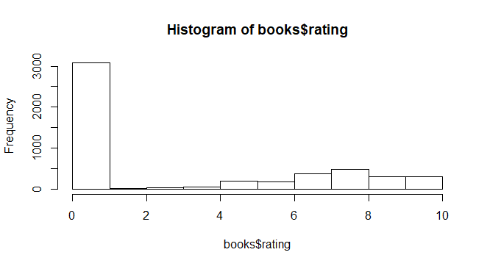

**The data type should be realRatingMatrix inorder to build recommendation engine**

> books_matrix <- as(books, 'realRatingMatrix')

> movie_recomm_model1 <- Recommender(books_matrix, method="POPULAR")

**Predictions for two users**

> recommended_items1 <- predict(movie_recomm_model1, books_matrix[413:414], n=5)

> as(recommended_items1, "list")

$`413`

[1] "1" "2" "3" "4" "5"

$`414`

[1] "1" "2" "3" "4" "5"

**Popularity model recommends the same movies for all users; we need to improve our model using Other Methods.**

1. **Collaborative Filtering**

> movie_recomm_model2 <- Recommender(books_matrix, method="UBCF")

**Predictions for two users**

> recommended_items2 <- predict(movie_recomm_model2, books_matrix[413:414], n=5)

> as(recommended_items2, "list")

$`413`

[1] "25" "26" "27" "28" "29"

$`414`

[1] "25" "26" "27" "28" "29"

1. **Matrix factorization with LIBMF**

> movie_recomm_model3 <- Recommender(books_matrix, method="LIBMF")

**Predictions for two users**

> recommended_items3 <- predict(movie_recomm_model3, books_matrix[413:414], n=5)

iter tr_rmse obj

0 2507.3806 3.1447e+010

1 2363.6649 2.7946e+010

2 2156.1229 2.3254e+010

3 1915.4870 1.8353e+010

4 1653.2911 1.3672e+010

5 1386.2079 9.6119e+009

6 1130.7615 6.3958e+009

7 899.9907 4.0517e+009

8 701.8138 2.4639e+009

9 538.9832 1.4533e+009

10 410.0751 8.4136e+008

11 310.9996 4.8402e+008

12 236.4947 2.7999e+008

13 181.2551 1.6457e+008

14 140.5882 9.9103e+007

15 110.6731 6.1507e+007

16 88.5663 3.9477e+007

17 72.0839 2.6234e+007

18 59.6456 1.8039e+007

19 50.1257 1.2812e+007

> as(recommended_items3, "list")

$`413`

[1] "4601" "4188" "3240" "327" "1625"

$`414`

[1] "2463" "4445" "3527" "1912" "468"

1. **RANDOM recommendations**

> movie_recomm_model4 <- Recommender(books_matrix, method="RANDOM")

**Predictions for two users**

> recommended_items4 <- predict(movie_recomm_model4, books_matrix[413:414], n=5)

> as(recommended_items4, "list")

[[1]]

[1] "4302" "3646" "1620" "3212" "4963"

[[2]]

[1] "938" "4790" "4976" "4819" "2272"

1. **RERECOMMEND Method**

> movie_recomm_model5 <- Recommender(books_matrix, method="RERECOMMEND")

**Predictions for two users**

> recommended_items5 <- predict(movie_recomm_model5, books_matrix[413:414], n=5)

Error in sample.int(x, size, replace, prob) :

incorrect number of probabilities

> as(recommended_items5, "list")

[[1]]

[1] "4302" "3646" "1620" "3212" "4963"

[[2]]

[1] "938" "4790" "4976" "4819" "2272"